

**Tel.**01387 254 424 @Allied_Scot

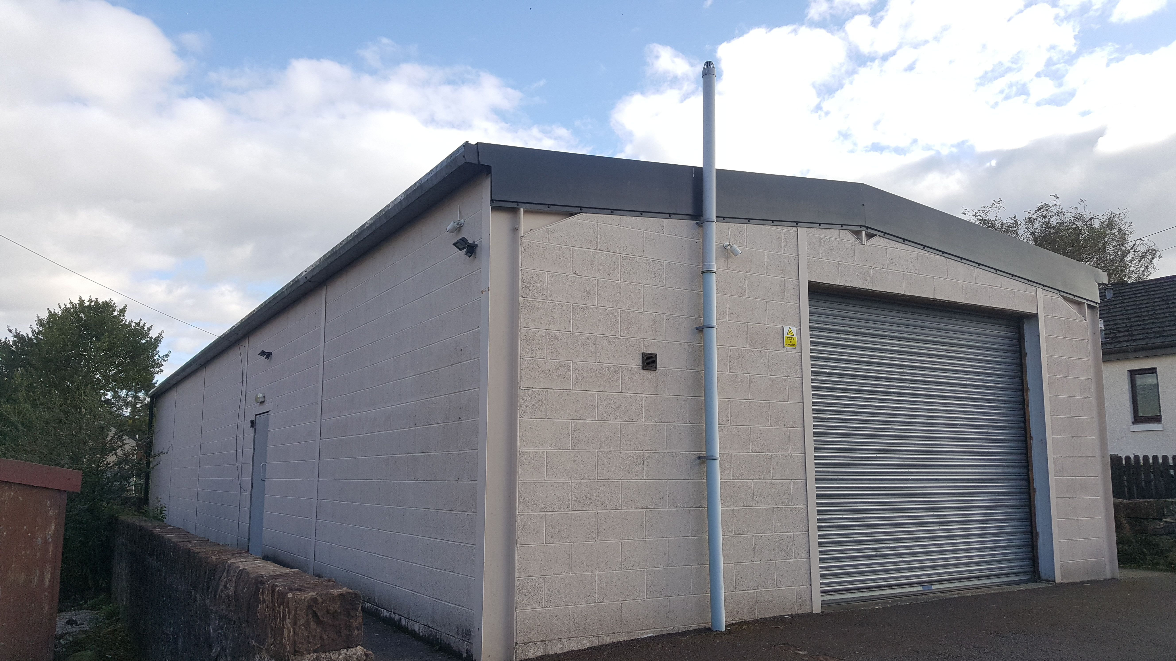

**TO LET**

**COMMERCIAL UNIT, BACK STREET, THORNHILL**

FLEXIBLE COMMERCIAL / LIGHT INDUSTRIAL SPACE

RECENTLY UTILISED AS A GYM

ON SITE PARKING

OFFERS FOR RENT - £8,500 P.A.

# 

# LOCATION

The subjects are situated near the centre of the town of Thornhill, just off the main thoroughfare.

# DESCRIPTION

The subjects comprise a detached, single story steel framed commercial unit.

The property has a hard standing to the front that can accommodate 3 vans / cars and a roller shutter that will allow a high top van clear access.

For added security and to allow varied use of the property no windows are in the walls, natural light is by 10 double skinned, in effect double glazed, large roof lights.

# ACCOMMODATION

The subjects offer flexible commercial space currently configured as a main floor with a single office and a w/c compartment.

# FLOOR AREA

We calculate the net internal floor area of the subjects to be 166m2 (1790 sq.ft)

Including:

|  |  |
| --- | --- |
| **Space** | **Area** |
| Main Area | 160m2  (1722 sq.ft) |
| Office | 3m2  (34 sq.ft) |
| W/C | 3m2  (34sq.ft) |

# 

# 

# RATING ASSESSMENT & USE

We understand the property is entered in the Valuation Roll with a Rateable Value of £4,000.

The property is therefore eligible for 100% rates relief under the Small Business Bonus Scheme Further information is available from [www.scotland.gov.uk](http://www.scotland.gov.uk).

The subjects have most recently been used as a gym but lend themselves to a range of commercial or light industrial uses subject to local authority approval.

**ENERGY PERFORMANCE CERTIFICATE**

Energy Performance Rating –

**TERMS**

Offers for let in the region of £8,500 per annum are invited

# SERVICES

The property benefits from mains electricity, water and drainage. The subjects are also understood to benefit from three phase electricity.

**VAT**

Not applicable.

# LEGAL COSTS

Each party to bear their own legal costs.

# DATE OF ENTRY

Immediate entry is available on conclusion of negotiations and signing of the lease.

These particulars were prepared on 1st October 2024, and have been carefully compiled and are believed to be correct. Any error or omission however shall not annul the let nor in any event give grounds for action at law.

MESSRS. G M THOMSON & CO for themselves and for the lessors/vendors of this property give notice that:

1. The particulars are set out as a general outline for the guidance of intended purchasers or tenants and do not constitute, nor constitute part of an offer or contract.

2. All descriptions, dimensions, area, photographs and reference to condition, necessary permissions for use and occupation, and other details, are given without responsibility and any intending lessees should not rely on them as statements or representations of fact but must satisfy themselves by inspection or otherwise as to the correctness of each of them. Where dimensions are shown these are approximate only.

3. No person in the employment of Messrs G M Thomson & Co has any authority to make or give any representations or warranty whatever in relation to these properties

**VIEWING AND FURTHER INFORMATION**

By appointment only through the sole letting agent G M Thomson & Co

Allan McMillan/Scott Morton| Tel. 01387 254 424

Allan.mcmillan@gmthomson.co.uk/scott.morton@gmthomson.co.uk